Customer Test Program

Customer | : | Weir Gabbioneta
Ultimate User | : | Sonatrach, Arzew, Algeria
Customer Reference | : | 12 MJ 30 A/B
Pump Manufacturer | : | Weir Gabbioneta, Sesto san Giovanni (Italy)
Roosendaal Test Project | : | 2017RSD10TL
Seal type and size | : | UMPW/DMP, 4.000/4.000
Flowserve order no. | : | 983444

Project | Prepared by | Approved by | Description | Date
2017RSD10TL-01 | W. Dsouza / D. Swinkels | K. Disco | Initial program | 9-Nov-17

CONTENTS PAGE
1. Introduction 1
2. Objective 1
3. Field Conditions 1
4. Test Conditions 1
5. Test Seal Configuration 1
6. Test Set-up 1
7. Test Procedure 1
8. Planning 1
9. Appendix I 1
10. Appendix II 1
11. Appendix III 1

Introduction

A mechanical seal was designed for a DSA 360/150 1 stage pump delivered by Weir Gabbioneta which is in operation at Sonatrach. It concerns a dual unpressurised face to back cartridge seal (assembly D0030176B) of which the inner seal shows leakage. In the Flowserve test lab, the inner seal (only) will be dynamically tested to demonstrate the performance on normal conditions.

Objective

The objective is to run performance tests with the UPMW, 4.000 mechanical seal cartridge. For this test a mechanical seal according Flowserve order 983444 will be used.

The acceptance criteria are:
- An average seal leakage rate of 20cc/hour per seal face pair, after run in period.
- No evidence of chipping or deterioration of the contact surfaces allowed.
- A maximum wear rate of 2.5x10⁻⁶ inch/hr (0.063 µm/hr) of the carbon seal faces.

Field Conditions

Seal type and size : UMPW/DMP, 4.000/4.000
Seal Configuration : Dual Unpressurized Face to Back Cartridge
Material code : 5XYY/5XYY
Pump fluid : Water, traces of Amdea solvent(Amine), CO2 0.04%mol,
Methane 0.0763%mol
Seal chamber pressure : 69.81 barG Nom / 79.74 barG Max
Seal chamber temperature : 61°C Norm / 43-62°C
Buffer fluid : Water
Buffer pressure : Atmospheric
Buffer temperature : Ambient
Speed : 980 rpm
API-plan : 11/52/61
Flowserve order number : 983444 (plan 52 083444R)
Assembly drawing : D0030176 rev. B (Appendix I)

Test Conditions

Seal type and size : UMPW, 4.000
Material code : 5XYY
Seal chamber fluid : Demineralized Water
Speed : 1050 rpm
API-plan : 54
Test project number : 2017RSD10TL01
Test assembly drawing : XD0379535 rev. (Appendix II)

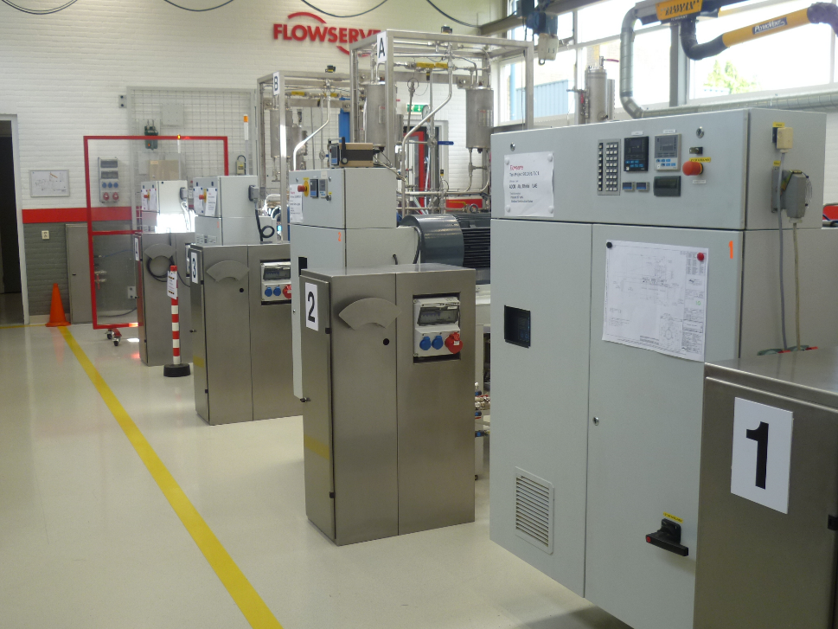

Figure1: Flowserve Seal Test Facility

Test Seal Configuration

Seal Type : UMPW-4.000
Rotating Face : 665937SL
Material : Reaction Bonded Silicon Carbide
Stationary face : 3N10746X851 (70% bal.)
Material : Resin Impregnated Carbon (FDA Grade)

Test Set-up
The test will be executed on test rig no. 4. This unit is equipped with a xx kW, frequency driven motor. Seal will be built as per drawing XD0379535 rev. (Appendix II). For testing, the seal with counter-clockwise rotation (free end seal) will be used.

The test housing will be assembled within maximum allowable angular and radial misalignment according to API-682 (third edition) section 6.1.2.8(b) and 6.1.2.13.

The product will be circulated at rated pressure and temperature using a Plan 54 system, a UMPW 4.000 will be used for the third stage “plug seal”. See annex II.
An air driven piston pump will be used to control the pressure of product in the seal chamber. Thermo-couples will be installed in the inlet (LBI) and outlet (LBO) piping to record the produce temperature.
Thermo-couple will be installed at the I.D. of the stationary seal face, which will record face temperatures.

Test Procedure

PRE TEST WORK
- At first installation the alignment of the Seal chamber will be measured and recorded;
- Prior to first installation all mechanical seal and test components will be inspected for proper construction, compliance to drawing and material;
- Check seal faces for flatness. If not flat within two light bands, re-lap the faces;
- A surface profile of the "running area" of both, the rotating and stationary faces will be recorded as well as the face roughness (Ra value). In case of carbon material the face height will be measured for future wear rate determination;
- The mechanical seal cartridge will be assembled according to installation instructions indicated on drawing XD0379535 rev. – (Appendix II). Thermo-couples will be added to the ID of the stationary seal face.
- Seal cartridge will be installed on the test unit and the Barrier Inlet and Outlet connected to the Plan 54 system.
- The barrier system will be statically pressurized to the dynamic test pressure for a period of 10 minutes to check the tightness of the mechanical seal assembly;
- The breakout torque will be measured immediately after pressurizing and after 10 minutes static pressurization.

DYNAMIC TEST
Following dynamic tests are programmed:

- Minimum 100 hours test with the original seal design. If after 100 hours the seal does not show a stable behavior the test will be continued till a stable performance is achieved.
- Change spring pressure to 30PSI and do test for 50 hours.

All tests will include three stops/starts. These stops/starts will be executed at the end of the test with an interval of 30 minutes.

The barrier flow will be determined during each test.
All other conditions are as described in chapter 4.0.

MONITORING OF DYNAMIC TEST
Seal Performance, by means of a data acquisition system the following parameters will be recorded with an interval of 5 minutes:
- Barrier inlet temperature;
- Barrier outlet temperature;
- Stationary face temperature;
- Barrier pressure.

By hand at regular intervals during day shift:
- Barrier inlet temperature;
- Barrier outlet temperature;
- Stationary face temperature;
- Barrier pressure;
- Barrier flow rate;
- Leakage of test seal as well as the plug seal;
- Power consumption.

POST TEST WORK
- Directly after the test is stopped the break-out torque will be measured under pressurized condition; This will be repeated 10 minutes after the first measurement;
- Drain seal and disassemble mechanical seal from test rig;
- The mechanical seal will be dismantled for inspection;
- Following parts will be inspected and observations recorded:
- Seal faces;
- Anti-rotating pins:
- Landing areas
- A surface profile of the "running area" of both, the rotating and stationary faces will be recorded. The face roughness (Ra value) will be recorded in radial direction. In case of carbon face material; the face height will be measured for seal face wear rate determination;
- Photographs of both rotating and stationary faces and bellows will be made;
- If carbon face material is used the wear rate will be calculated.

REPORTING
- Every deviation from the test program will be recorded with a Test Program Change Notice (TCN);
- A detailed test report will be written after completion of the complete test program.

Appendix I

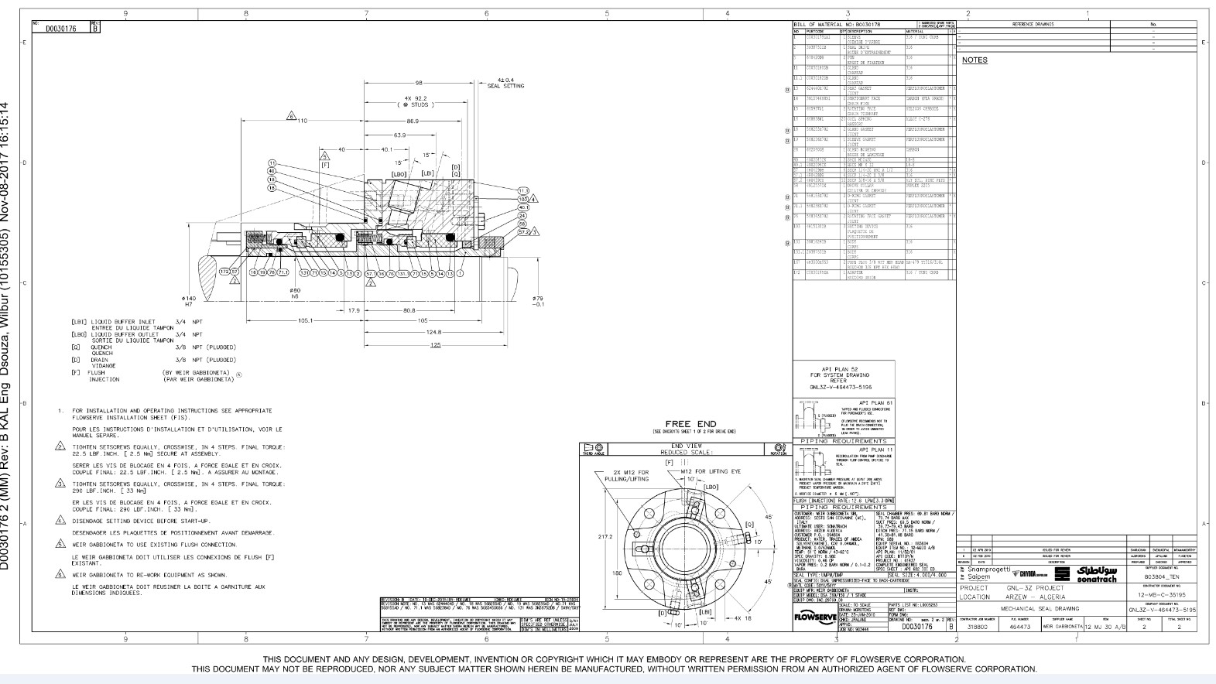

Appendix II

Appendix III
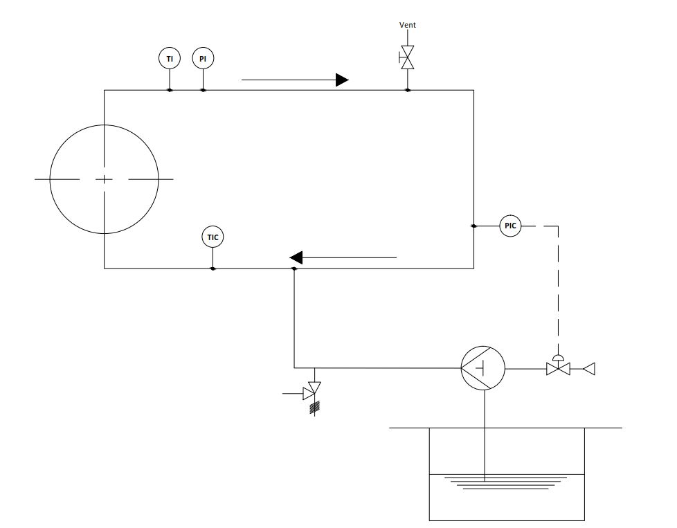

PI - Pressure Indicator
PIC - Pressure Indicator / Controller
TI - Temperature Indicator
TIC - Temperature Indicator / Controller

